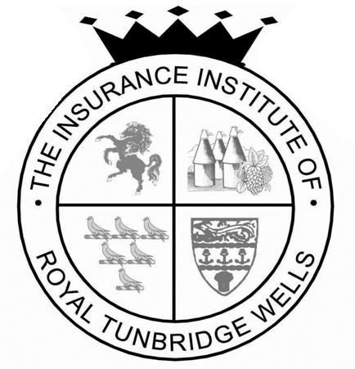

The Insurance Institute of Royal Tunbridge Wells
23rd February 2018 Annual Dinner Booking Form

No. of tickets required (e.g 10 @ £50.00 per head totalling £500.00).

No……………………@£50 per head totalling £…………………..

Contact
Company
Telephone Number
Email

Table Plan
Note: Ideal 10 persons per table with a maximum of 12. Unfortunately, parties of 6 or less may not be able to be seated on an exclusive table. Please contact us if you have a specific request and we will do our best to accommodate.

Name | Starter | Main | Dietary
1
2
3
4
5
6
7
8
9
10
11
12

PAYMENT: please make your payment by BACS to:
Tunbridge Wells Insurance Institute
NatWest Bank
Account Number 08418063
Sort Code 55:70:13
And please remember to quote your company name

and then e-mail a copy of this booking form to: The Dinner Secretary at
rebecca.eastwood@fosterdenovo.com
or you can telephone me on 07793 241323

If you would like to discuss supporting this event please let me know.

