Did someone say SUMMER?
Summer of 2018 is now fully into swing, beautiful summer days, and even better summer evenings.
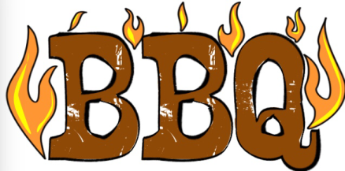
The Insurance Institute of Ipswich Suffolk and North E ssex would like to make your summer a memorable one. We’d therefore like to invite ALL to join us for this year’s Summer BBQ.

Southern Fried Cajun Chicken
Pork and Herb Sausages
Quarter Pounder Beef Burgers
Salad
Sweets
*Vegetarian options available*
Rounder’s @ 9pm
Tin Can Alley
Connect 4
Jenga
Skittles
24th August 2018
Gresham’s Ipswich
312 Tuddenham Road
Ipswich
IP4 3QJ
Time: 6pm until Midnight
Ticket Price: £30
DJ, Games, BBQ and more.
The Insurance Institute of Ipswich, Suffolk and North Essex would like to invite all to join us at Gresham’s, Ipswich on the evening of Friday 24th August 2018 for this year’s Summer BBQ.
The event includes a DJ from 8pm, a selection of BBQ foods and also a selection of summer games.
It will be a great opportunity to network with the CII and PFS community for our local area, helping to build your network base, whilst also enabling you to make the most of the beautiful UK summer.
If you’d like to attend our Summer BBQ, why not get a group of you together and make this summer evening one to remember. Please book your place via our website. If you have any questions, you are a vegetarian or have any dietary requirements, please contact:
Jess Addison @ jess.addison@willistowerswatson.com, Tom Chambers @ tom.chambers@axa-lm.com or Laura Blyth @ blythl@wmibl.co.uk.
We look forward to seeing you there…
The Insurance Institute of Ipswich, Suffolk and North Essex

