**Careers sub-committee Annual Report 19th March 2020**

We have had some new leaflets and merchandise from CII HQ for next year’s career events.

March 2019 - Kayleigh, Greg, and Ian presented to over 70 people in an earlier careers session and we received some lovely feedback from the college.

3rd October 2019 - Andrew hosted a successful Careers Event at the Bolton School

14th November 2019 – University of Bolton with Gary Ward, Paul Cooper and Julie Watson which emptied our full stock of flyers.

21st November 2019 Joanne Hosted a successful event at Canon Slade School

4th March – Careers Day with Joanne at Canon Slade School , linking in with Rebecca from Biba

5th March – Wigan and Leigh School “discover risk” workshop session with Paul Cooper and Julie Watson

Andrew now has a contact at Bury Grammar School (Hannah Greene, Head of Careers) who has confirmed they are happy to work with the CII and incorporate us in their upcoming careers events. Also, they have asked if we can support them from a summer work placement perspective.

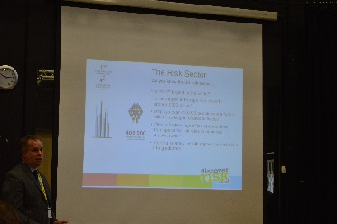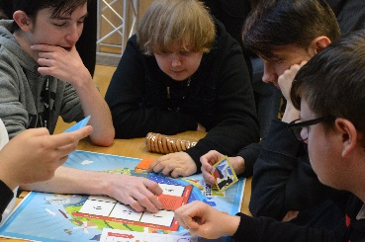Earlier in 2019 we had a small mention in *The Journal* and some pictures from the *Discover Risk* session at Wigan and Leigh College on 07th March 2019:

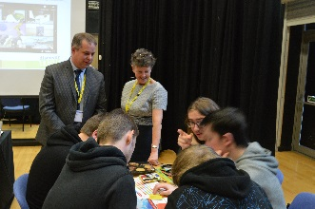



A big thank you to everyone who ran or assisted in a careers event in 2019/20 and look forward to a successful year ahead.

Kind regards

Philip Roath