Connect! Effective Remote Relationships in a Digital World
Professional relationships have always been vitally important. To succeed in the rapidly changing world, we need to ensure we can build relationships remotely in a virtual format. Virtual meetings have their own unique challenges and surprising benefits. This event shows you how to create the right professional impact, develop a future fit mindset, build remote relationship skills and the confidence to thrive in the emerging digital environment.
Learning Objectives

- Your Remote Mindset: Virtual Identity + Virtual Presence
- Amplifying Virtual Relationships
- Enabling Professional Relationships with Digital Tools + Tech
- Planning Successful Virtual Meetings
- Overcoming Challenges and Thriving in a Virtual World

1.5 hrs Interactive, tips and strategies.

Speaker Bio
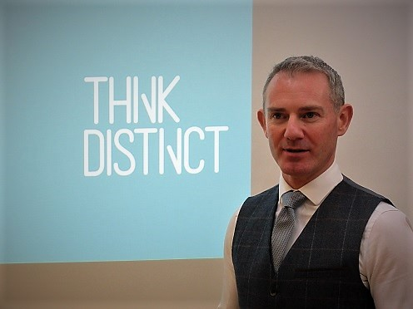
Andy Currie is the Founding Director at Think Distinct Ltd, a unique consultancy that helps individuals and organisations develop a productive advantage through high performing Thinking, Learning and Leadership. As an Executive Coach and faclitator he has worked with thousands profesionals across the UK and internationally, to improve their ability to change, think more strategically, communicate and create switched on learning teams. He builds unconventional, high precision behavioural programmes, delivered with a twist and lashings of sound business insight, targeted to deliver specific measurable results. He is a Certified Professional Behavioural Modeller, an expert in Applied Developmental Behavioural Modelling, A Certified NLP Trainer and Systemic Coach and a graduate in Psychology. To find out more about his work, email andycurrie@thinkdistinct.co.uk or visit www.thinkdistinct.co.uk

