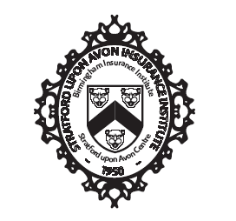

AGENDA of council meeting

The President held a Council Meeting on Wednesday 12th October 2022 virtually via Microsoft Teams.

Attendees: Samm Lees (SL), Neil Aston (NA), Chloe Callery (CC), Jamie Glover (JG), Jonathan West (JW)

- Apologies
Olivia Saddleton (OS), David Oram (DO), Ewart Hodge (EH), Sue Davies (SD), Marc Moon (MM)

- Minutes & actions from previous meeting

Action 29/06/22: Everyone – send SL and picture of yourself and mini blurb about yourself. UPDATE 29/07/22 – carry forward. Update 24/08/22 – everyone to send to Samm by Friday 26th. CARRY FORWARD- DEADLINE 21ST OCT
Action 24/08/22 - EH will reach out officially to a contact to see if they can provide educational output and then we can agree timescales. – update 14/09 – carry forward.
Action 24/08/22 - OS to reach out to D&I to see what they can offer. 12/10 CLOSE

- Lectures & Syllabus

Updated on D&I lecture suggestions. OS to progress and establish provisional dates.

ACTION 12/10/22: SL to meet with EH to establish Nov – April syllabus.

- Regional Forum
.

- Officers' Reports

  - Secretary

No update.

  - Treasurer

No update.

  - Education Secretary

No update.

  - Annual Dinner Secretary

No update.

  - Press Officer

No update.

  - Membership Secretary

No update.

  - Social Secretary

No update.

  - Charities Secretary

No update.

  - Diversity & Inclusion Secretary

No update

- Any Other Business

NA raised suggestion of a ‘professional headshot’ social- maybe following a lecture, or as a lunch session, with tea/ coffee/ sandwiches, encouraging networking and getting a new headshot. ACTION 12/10/22: One for MM to consider?

