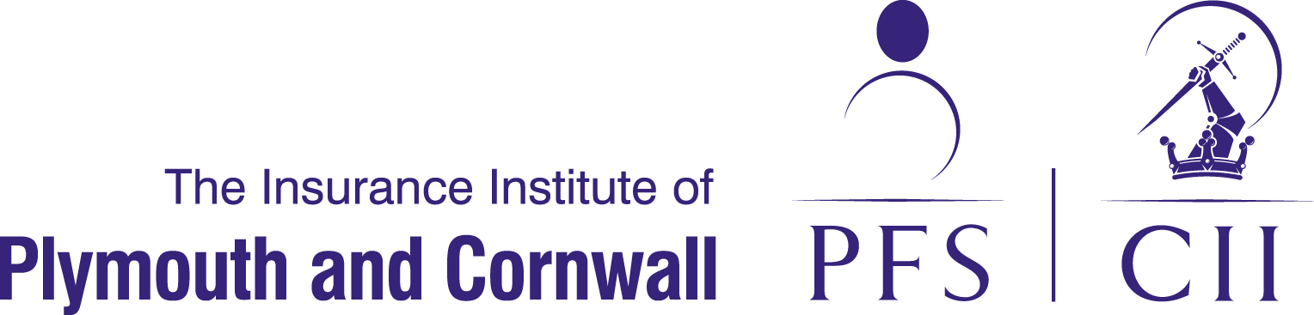

Annual Dinner
The Duke of Cornwall Hotel, Plymouth

Friday 21st October 2016
BOOKING FORM
Please note that this year the seating will be in the form of circular tables for 10.
Names of Guests – First Table |  |  | Names of Guests – Second Table
1. |  |  |  | 1
2 |  |  |  | 2
3 |  |  |  | 3
4 |  |  |  | 4
5 |  |  |  | 5
6 |  |  |  | 6
7 |  |  |  | 7
8 |  |  |  | 8
9 |  |  |  | 9
10 |  |  |  | 10
Name & Address of your Company:
Contact: Tel. No: Email:
No. of guests: x £50.00  TOTAL £ .  payable to:  The Insurance Institute of  Plymouth & Cornwall |  | Please return to:  Miss Karen Goss  (Please mark as Private & Confidential)  c/o WPS Insurance Brokers,  Spargo House, 10 Budshead Way  Plymouth PL20 7LS  Please note that payment must be enclosed with your booking form.

