2020 Vision; A General & Financial Services Conference

Welcome to the 2020 Insurance Institute of Bristol conference. The event promises to deliver a great day of professional development and networking with your fellow members and professionals. An outline of the event’s agenda is detailed below, and you can read more about the sessions overleaf.

Please let us know what you think of the event by completing the online feedback form via the link sent to you after the conference. We would welcome constructive feedback on how to make the event as useful as possible to our delegates. Your CPD Certificate will be available to download after you have submitted your feedback.

We hope you have a fantastic day!

Date
Thursday 23 January 2020
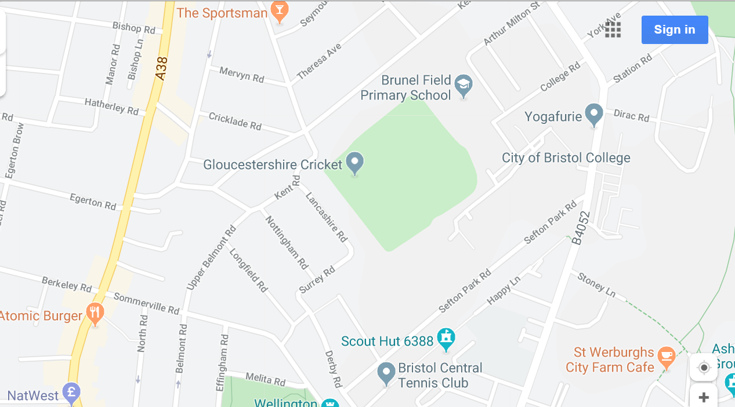
Location
The Bristol Pavilion
Gloucestershire Cricket
The Brightside Ground
Nevil Road
Bristol BS7 9EJ

Travel & Car Parking

DRIVING
Exit M32 at Junction 2 (Fishponds and Horfield). Take the exit off the roundabout - Muller Road - AA signposted ‘County Cricket Ground’. If coming from the north (M4) this is the 3rd exit, if coming from the City Centre this is the 1st exit. After approximately 1 mile turn left into Ralph Road. At the end turn left and then first right into Kennington Avenue. At the T junction turn left into Nevil Road and the Grace Gates are in front of you. Note: Some Sat. Nav systems show Lancashire Avenue for postcode BS7 9EJ. This road borders the County Ground, off Nevil Road where the entrance is located.

PARKING
Free on-site parking via Nevil Road entrance. For special access needs or other requirements please contact the venue direct.

PUBLIC TRANSPORT
RAIL:
Bristol Temple Meads train station (City Centre) is approximately 2 miles from the County Ground; taxi fare approximately £9.00. Bristol Parkway station is approximately 3 miles from the County
Ground & located north of the city

BUS:
From the City Centre, services 73, 75, 76 and 77 will take you along the Gloucester Road and bring you within 100 yards of the County Ground. From Bristol Temple Meads railway station, Nos. 8 or 9 will take you to the bus station and then catch one of the above from the Central Bus Station, the No 70 runs to Ashely Down Road, to the rear of the cricket ground or No 71 takes you directly from Bristol Temple Meads to Gloucester Road.

We will be taking photographs throughout this event which may be used on our website and social media to promote the activities of the Insurance Institute of Bristol. If you do not wish your picture to be taken or used in this way, please make sure you let the organisers know when you arrive.

Refreshments
Tea, coffee & juice will be available during the refreshment breaks. A buffet lunch will also be provided.

If you have any special dietary requirements or any other particular needs that were not stated on your booking form or advised to Emily Westacott subsequently, please contact emily.westacott@cii.co.uk to discuss.

Dress Code
Business attire for the day

Wi-Fi
Free Wi-Fi will be available to all delegates and the code will be advised on the day

Conference Chair
Richard Smith FCII, Vice President, Insurance Institute of Bristol

Conference Manager
Emily Westacott, Regional Membership Executive, Chartered Insurance Institute

Conference Speakers
Chris Morter ACII President, Insurance Institute of Bristol
Matthew Hartigan ACII HIGOS Insurance Brokers Ltd
Alex Tong ACII QBE
Jason Howes A.inst.S.M.M Allianz
Karen Brown ACII Insurance Institute of Bristol
Sandra Paul Prestwood Software Ltd
Steve Green ACII Steve Green Consultancy Ltd
Steve White BIBA
Deepak Sohal Cert CII Zurich
Andrew Burton Andrew Burton Coaching Ltd
Alison Cooper FCII Dip PFS ACT One Training Services Ltd
Fran Burgess Zing 365 Ltd
Melissa Collett Chartered Insurance Institute
Debbie Sturge ACII University of West of England

AGENDA

8:30 – 9:15 Registration, refreshments and networking

9:15 – 9:30 Welcome
Richard Smith FCII, Vice President, Insurance Institute of Bristol
Chris Morter ACII, President, Insurance Institute of Bristol

9:30 – 9:45 Opening Address
Steve White, BIBA

9:45 – 11:00 Plenary & Question Time
Matthew Hartigan ACII, Managing Director, HIGOS Insurance Brokers Ltd
Alex Tong ACII, Southern Regional Manager, QBE
Jason Howes A.inst.S.M.M, Southern Regional Manager, Allianz
Karen Brown ACII, Past President, Insurance Institute of Bristol
Sandra Paul, Prestwood Software Ltd
Steve Green ACII, Managing Director, Steve Green Consultancy Ltd
Steve White, CEO, BIBA

11:00 – 11:15 Refreshment Break

11:15 – 11:30 MSc Risk Management and Insurance
Debbie Sturge ACII, Course Director, University of West of England

11:30 – 12:40 Carousel Sessions
Please choose 2 sessions and email emily.westacott@cii.co.uk with your choices
Cyber Insurance into 2020 & beyond; Deepak Sohal Cert CII, Zurich
Give clients confidence and clarity using cashflow modelling; Sandra Paul, Prestwood Software Ltd
Wellbeing in Insurance and Financial Services; Andrew Burton, Andrew Burton Coaching Ltd

12:40 – 13:30 Networking Lunch

13:30 – 14:00 Chartered Insurance Institute
Melissa Collett, Director of Professional Standards, CII

14:00 – 15:10 Carousel Sessions
Please choose 2 sessions and email emily.westacott@cii.co.uk with your choices
Financial Resilience for Women, Alison Cooper FCII Dip PFS, ACT One Training
Services Ltd
Embedding/Value of Learning Culture in Insurance and Financial Services, Fran Burgess,
Zing 365 Ltd
Professional Standards, Melissa Collett, Director of Professional Standards, CII

15:10 – 15:30 Refreshment Break

15:30 – 16:00 Closing Address

16:00 Conference Closes
Bar & networking

