SAFE Meetings & Events
What we’re doing to keep you safe

At Sandy Park we are doing everything we possibly can to ensure the safety and wellbeing of our customers and staff are in line with the very latest Government advice relating to COVID-19.
During the lockdown period we have not only reinforced our already exceptional standards but have set out some new guidelines when running your event at our venue to keep everyone safe.

Our 5-point plan to make Sandy Park a safe venue
Space & Social Distancing
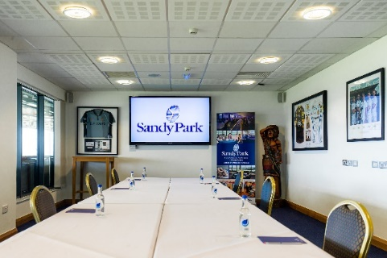
All rooms will have social distancing measures and clear signage and guidance around the venue
Hygiene & Cleanliness
New and improved cleaning procedures and providing a high level of hand sanitiser dispensers

Contact Free Catering
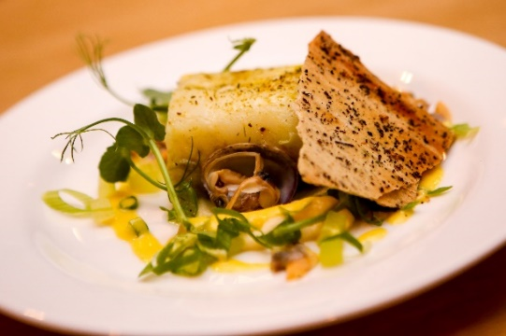
Food and drink prepared with increased safety and maintaining Sandy Park’s range of fresh produce
Staff Training
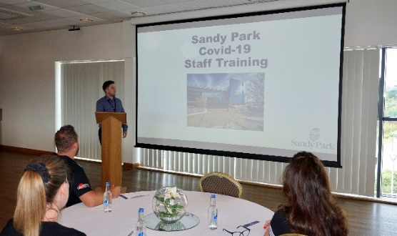
All staff working to new operational procedures and have PPE tailored to their role
Communication
Regular updates from our Event Co-ordinators

Parking
Our large, spacious car park allows for effective spacing and is assisted by signage.
For your safety, all clients will be advised to use the RingGo app to manage parking charges
Location number 9168
Clients that use the Parking Tablets to cover the cost of their parking will be asked to have a designated organiser to enter the vehicle registrations for all of their attendees
Entering & Exiting
There will be clear signage and floor markings throughout the building, where we will be advising clients to keep to the LEFT to help with social distancing.
Guest lifts will be limited to those with accessibility needs and capacity reduced to two persons maximum.
Any conference deliveries need to be arranged at least 72 hours prior to the event to ensure we are able to operate the correct safe handling procedures.

Monitoring and Tracking
If you or any of your guests have COVID-19 symptoms or are feeling unwell, we ask that you do not visit Sandy Park. Any guests displaying any symptoms will be asked to kindly return home.
In addition, we ask that any guests who develop symptoms in the week after attending an event a Sandy Park contact us immediately to ensure that we can take the correct procedures internally.
Event organisers will need the contact details of all their guests attending any event at Sandy Park. This to ensure we are able to carry out contact tracing should it be necessary.
The NHS Test & Trace QR Code is displayed on arrival where attendees are encouraged to scan and check -in
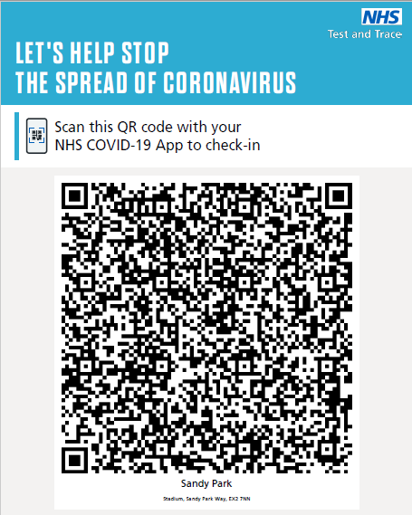

Meeting Rooms
Meeting spaces will be allocated in order to keep each event separate and provide a one way entrance and exit system where possible.

Cleaning Procedures
Sandy Park will be cleaning all areas to the standards set out in Public Health England Guidance for non-clinical settings. Additional measures will include:
- Frequent cleaning of high-touch surfaces throughout the day (door handles, handrails etc)
- Provision of hygiene stations throughout the building
- Regular cleaning of high traffic areas such as reception, stairwells and corridors
- Hand-sanitising stations around the building to allow frequent use

Food and Beverages
Access to any food and beverage areas will be controlled and limited, for example:
- Limit on number of people in the area at any one time
- Hand sanitiser stations will be available in these areas

Given the ever-changing nature of this situation, we have evolved our food and beverage offering:
- Water will be served in individual bottles for each person
- Pre-packed ‘grab and go’ meals served in environmentally sourced disposable packaging
- Where possible, food items will be individually packaged or wrapped
- Cutlery will be pre-wrapped and provided on an individual basis

Client show rounds
Clients must have a pre-arranged appointment to visit Sandy Park and will be asked to follow our Entering & Existing procedures.

Booking Procedures
Clients will be required to agree and sign our updated booking Contract and Terms & Conditions prior to their event date.
We will also provide our Covid-19 Risk Assessment to all clients ahead of their booking

Personal Protective Equipment (PPE)
To ensure the safety of our guests and staff, Sandy Park will be providing all our staff with PPE tailored to their job role.
All Front of House staff will be provided with masks and gloves
All staff involved with food preparation will be required to wear face coverings and aprons. Plastic gloves are not recommended due to the HSE risk of cross contamination across foods, however regular hand washing after handling foods is mandated
Staff
All our staff have been given rigorous training in procedures and protocols to mitigate COVID-19 transmission, deal with an incident promptly and effectively in the event it should occur - and to ensure customers enjoy a safe experience here at Sandy Park.
In addition, they conduct fit to work questionnaires before setting off for work and are individually temperature screening before accessing the site.

Waste Procedures
Sandy Park will continue to focus on improving our environmental footprint and will recycle waste wherever practicable to do so – we ask all of our customers to support us in this aim

We will continue to review our procedures and update our clients on further measures that we will be adopting to keep our clients safe.

We look forward to welcoming you back to Sandy Park soon.

