THE HIGHWAY CODE 2022
Although they may have flown in under the radar, some very important changes were made in January to the Highway Code, known in some quarters as the ‘Road Users Bible’. Some drivers will be blissfully unaware that anything has changed, whilst many others will have a vague awareness that something has happened without understanding the detail. In fact, not only do the updates comprise essential information for virtually everyone, there are direct implications for anyone paying Motor insurance premiums.
The Changes.
- The most significant amendment is that a ‘hierarchy’ of road users has been established. This is neatly summed up by the Department of Transport thus:-
'Those who can do the greatest harm to others have a higher level of responsibility to reduce the danger'.
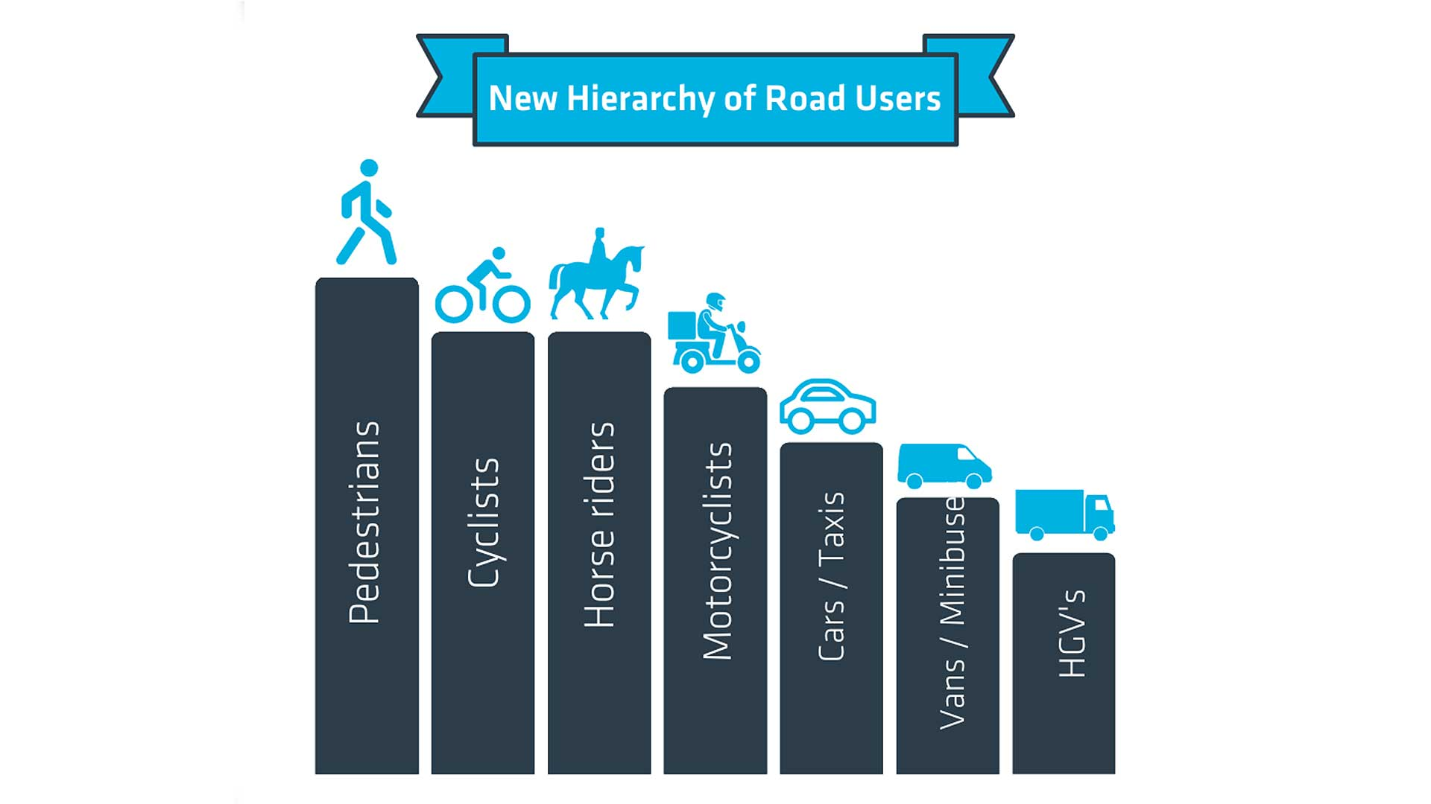
‘Motoring Research’

Quite simply, the higher the column, the higher the priority for that particular group of road user.
Ever since roads were first built, the guiding principle has been that if 2 parties were equally liability for an accident, liability was deemed to be split 50/50, irrespective of the mode of transport.
Not so now. In the case of disputed liability, there is every likelihood that the party at the lower end of this pecking order would be found to have the greater, if not all of the liability share.

- Drivers must give way to pedestrians at junctions. It is a driver’s responsibility to look out for pedestrians (and other higher priority road users) even if they are still on the pavement at the time. So for instance, if a pedestrian is intending to cross a side road into which a motorist is turning, the onus is on the driver to be aware of the likelihood of the pedestrian stepping into the road and act accordingly.
- Similarly, motorists must give way to anyone waiting to use a pedestrian crossing. Previously this was only a requirement once the pedestrian had stepped onto the crossing.
- Cyclists are entitled (even encouraged) to ride 2 abreast and to ride in the centre of a lane in urban areas. In other words, they should position themselves where they are most visible and feel safest. Drivers must allow a space of at least 1.5m when overtaking cyclists.
- Furthermore, motorists are expected to be aware of cyclists approaching from behind, even from some distance away. So in this case the previously universal rule of not overtaking on the inside no longer applies.
- Any use of hand-held mobile phones is banned, other than in an emergency. If this seems like a repeat of the current position, it does in fact close a loophole in the previous outdated Code, which banned the use of phones only for calls and texts. Sensibly, this now extends to the use of a phone for any purpose other than 999 calls and brings the Code into line with the relevant statute.
- An extension of penalty fines for minor offences. This relates to such misdemeanours as illegal U-turns, not giving way and blocking a box junction. Fixed penalties can now be given by local authorities as well as the police.
- The ‘Dutch Reach’. By opening a car door with the hand furthest away from it, the body naturally turns side-on. This prompts the driver or passenger to check behind for cyclists etc before opening the door.
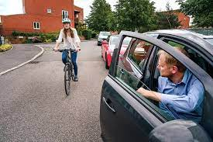
cyclinguk.org

It should be noted that all road users are still required to have regard to the safety of themselves and others. The Highway Code is for guidance, not statute. However, the practical effect will be that drivers of the potentially more dangerous vehicles will bear the onus of disproving any allegations of liability.
The terms of the new Code mean that there will inevitably be cases where insurers of larger vehicles have to deal with claims which would otherwise be unproven or settled by split liability.
From an insurance point of view it may be difficult to see any positives in this for drivers or owners of motor vehicles, particularly larger goods carrying ones.
However, the longer-term objective is to reduce speeds, lessen the frequency of accidents and limit the extent of injury and damage when they do happen. It might just be that, when said drivers and vehicle owners are using the roads in their capacity as pedestrians or cyclists, they might just find the roads a little safer, which after all is the whole purpose of the exercise.
All drivers should be aware of the full extent of the new Code, which can be referenced at https://www.gov.uk/government/news/the-highway-code-8-changes-you-need-to-know-from-29-january-2022
As a matter of good practice, employers should ensure that anyone driving on their business is provided with details of these important changes.

Bernard Thornton FCII
bernie.thornton@outlook.com
January 2022

