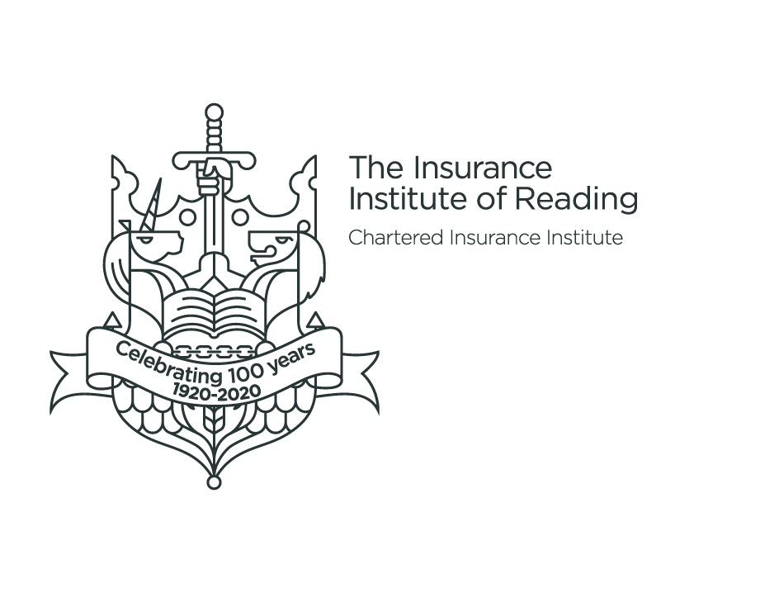
102nd ANNUAL GENERAL MEETING

Tuesday 10th May 2022
5.30pm
at
Soane Space, Reading Town Hall,
Blagrave Street, Reading

AGENDA
Ordinary Business
- Apologies
- Minutes of the 101st Annual General Meeting held on 6th May 2021
- Matters Arising
- Secretary’s report –Karen Rose
- Treasurer’s report- Karen Rose
- Election of President, Vice Presidents, Deputy President and Officers
- Election of council members
- Election of auditors for 2022-23
- Investiture of new President
- Presentation of Past President badge
- Outgoing/incoming President address
Special Business
- Transfer of office
- Adopt new constitution
- Date of next year's AGM
AOB -
CLOSE
NB Attendance at this meeting is open only to members of the Insurance Institute of Reading
Karen Rose, FCII, CFIRM, Chartered Insurance Practitioner, Certified Risk Professional
Secretary and Hon Vice President for Life
March 2022

