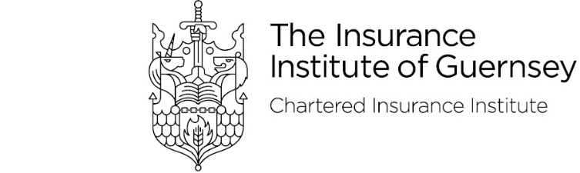

Annual Dinner – Friday 7 October 2022
Attendee Details

Details of guests and menu choices should be emailed to iiglunch@islands.gg by Friday 23 September
Please note that the start time of the dinner is 6.45pm and the bar will shut at 12pm.
Place cards will be produced by the Duke of Richmond based on the information provided below
The dress code is black tie

Guest Name | Starter | Main | Dessert | Dietary Requirements

Stephanie Bougourd & Kelly Fallaize, Insurance Institute of Guernsey
Dinner Secretaries

