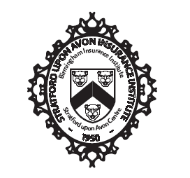

AGENDA of council meeting

The President held a Council Meeting on Wednesday 14th September 2022 virtually via Microsoft Teams.

Attendees: Samm Lees (SL), Olivia Saddleton (OS), Neil Aston (NA), Chloe Callery (CC), Ewart Hodge (EH), Jamie Glover (JG), Marc Moon (MM), Sue Davies (SD),

- Apologies
Jonathan West (JW), Hannah Lucas (HL), David Oram (DO),

- Minutes & actions from previous meeting

Action 05/04/22: SD to look into ‘Harvesting your Inner Critic’. Update 29/06/22 – carry forward. UPDATE 29/07/22 – SL to send SD an email. Update 24/08 – carry forward. Update 14/09 closed, SD sent through to SL.
Action 29/06/22: Everyone – send SL and picture of yourself and mini blurb about yourself. UPDATE 29/07/22 – carry forward. Update 24/08/22 – everyone to send to Samm by Friday 26th.
Action 24/08/22 - EH will reach out officially to a contact to see if they can provide educational output and then we can agree timescales. – update 14/09 – carry forward.
ACTION 24/08/22 - SL to share letter with council. – update 14/09 closed.
Action 24/08/22 - OS to reach out to D&I to see what they can offer.

- Lectures & Syllabus

- Regional Forum
.

- Officers' Reports

  - Secretary

  - Treasurer

  - Education Secretary

  - Annual Dinner Secretary

MM to have a think about some ideas.

  - Press Officer

  - Membership Secretary

  - Social Secretary

  - Charities Secretary

  - Diversity & Inclusion Secretary

- Any Other Business

Socials
SL will distribute letter following meeting with the central CII body. SL and other presidents have gathered to try to find out more what we need.
They are struggling with CPD – there are central audits to what we want.

NEXT MEETING TO BE ABOUT CPD

