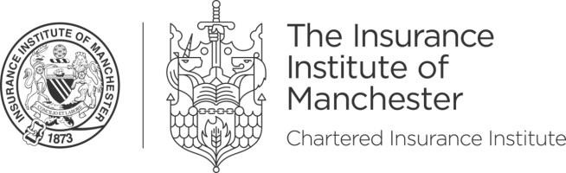

🌈 Manchester Pride

Sponsorship 2023 🌈

In the 150th year of the Insurance Institute of Manchester, we are delighted to support the Manchester Pride Parade on Saturday 26th August. 2023 is the second time the institute has taken part in the parade, and this year is bigger and better and we are offering a chance for local businesses to sponsor.
Tha parade has the theme of "Queerly Beloved" aiming to commemorate the 10-year anniversary of marriage equality in England and Wales. If you are wondering what to where to the parade, think wedding party (with comfortable shoes!) and brilliant accessories.
The package includes the following points to encourage your involvement in the event and prominence in the market:

Around the event buildup:
The IIM has over 5,300 members and works with further firms and individuals across the wider Manchester market.
- Your logo on the event page on the IIM website
- LinkedIn post from the IIM tagging your company’s involved in support the event
- Your involvement in the parade, including permit and associated costs, is all organised by the IIM

During the parade:
The parade takes place with over 4,000 participants and 170,000 visitors over the weekend providing a wider opportunity for brand exposure supporting the LGBTQ+ community.
- Refreshments provided in the area awaiting the event start
- Up to 10 spaces in the IIM parade section reserved for your staff and guests to take part
- Your company logo on the IIM big parade banner representing the walking party
- Sashes, flags, whistles, confetti and face paints will be provided to enjoy in the parade
- Opportunity to join our post-parade drinks to relive your Pride experience and network with your fellow walkers

Price: £300

To confirm your involvement, contact Adrian and provide your logo and LinkedIn page details.
CONTACT:

Adrian Golifer, Diversity Co-ordinator E: adrian.golifer@createsolutions.co.uk or T: +44 (0)7496 320 365
E: lii.manchester@cii.co.uk W: cii.co.uk/manchester
Don’t Miss Out: Annual Dinner 2023!
On Friday 10th November the IIM is hosting our Annual Dinner black tie event from 18:00 at the Kimpton Clocktower Hotel. Join us for the biggest night of networking in the Manchester market. Visit cii.co.uk/manchester for further details and to buy tickets.

