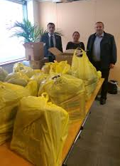 | THE BII BAG DROP  2nd - 6th NOVEMBER 2015  #BIIBagDrop | 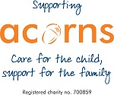

This year we will be doing another Bag Drop in aid of Acorns. Last year we helped to raise over £800 by donating our items. For each bag of items donated the charity receives approximately £10.

If you are looking to make a little more room for all those Christmas presents, rather than throw these items and unwanted gifts from last year away, why not give them to charity?

We will also be very happy to take any surplus holiday currency you have as Acorns are able to exchange this to sterling, so any spare Euros, Dollar, Rupees or even Peso’s.

Items donated in this way can be sold in Acorns' chain of shops to help fund their vital work with local children who are life limited and life threatened.

60 collection bags of good quality donated items can raise enough money to cover the cost of a full days care for a child at one of Acorns' hospices.

Items can include:

For Retail Shops  - New or worn clothes  - Books, DVDs, games  - Pretty much anything goes! | For the Hospice  - Arts & crafts materials e.g. paints  - Bedding e.g. duvets, pillow cases  - Toiletries, for both children & parents  - DVDs X-box games, Wii games

Bags will be available soon and sent to all offices that require them. Once they have been filled up we can arrange for them to be delivered to one of the collection points below:
- Rachel Sudlow - ACE European Group, Innovation Court, 121 Edmund Street, Birmingham B3 2HJ
- Hayley Reid - BHSF, Gamgee House, 2 Darnley Road, Birmingham B16 8TE
- Brian Rainbow - AXA, St Philips Point Temple Row, Birmingham B2 5AF
It would be great to see pictures of the items you collect, and you can either contact us via Twitter @BirminghamCII or use the hashtag #BIIBagDrop in both the lead up and during the week.
We thank you for your support.

