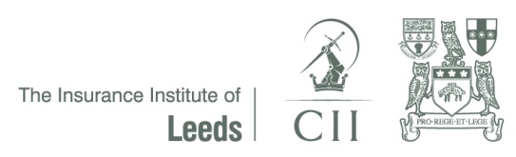

INSURANCE INSTITUTE OF LEEDS
128th ANNUAL DINNER CELEBRATION
Friday 4th NOVEMBER 2016

BOOKING FORM

Company:

Address:

Contact Name:

Telephone Number:

Fax Number:

E-mail address

Total Number of Tickets Required

Company | Number |  | Total
 |  | @ £60 each | £

Sponsorship Packages

My company is interested in discussing sponsorship packages | YES/NO
My company is interested in donating a raffle prize | YES/NO

Completed forms should be returned by e-mail to leedsinstitute@cii.co.uk

If you prefer please send by post to: –
The Insurance Institute of Leeds
c/o 4th floor Barlow house
Minshull Street
Manchester
M1 3DZ

This application form must be submitted no later than Friday 12th August 2016.

