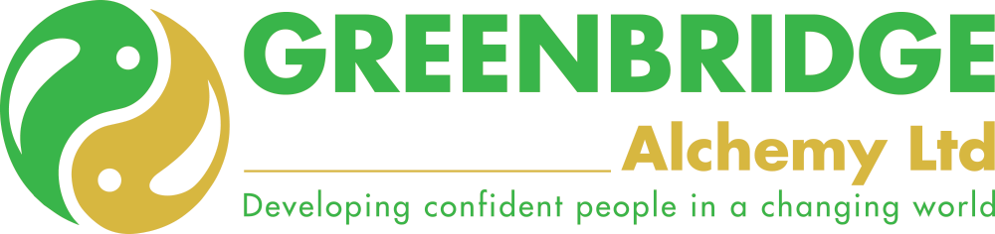
CONFLICT RESOLUTION
DEFINITION

Conflict happens when two or more parties one usually with more power, assert that they have a right to a limited resource or a course of action and those involved in the situation can frustrate the desires of the other(s).

Note: A subject cannot negotiate with a dictator; only another dictator can do that. Unfortunately, history has taught us that might is right.

Benefit to conflicts?

- It can promote growth, through learning to overcome challenges in unison with others
- It promotes creativity and innovation as solutions are suggested to overcome the differences between the stakeholders
- It promotes the development of interpersonal skills, as individuals strive to get on with each other in spite of their differences
- It promotes mutual understanding of different values, aspirations and cultures (sometimes people are not trying to be difficult, they just have a different mind set)
- It promotes social change and progress, as society changes and develops and a culture unfolds
- It promotes growth as the process of resolution overcomes stagnation of the status quo (necessity is the mother of invention and conflict is one of necessity’s prodigies)
- It can promote originality and reflection when your viewpoint is challenged.

Adverse costs of conflict?

- Higher stress amongst the parties
- Lower productivity as effort and resources are redirected into the conflict and away from the work in hand
- Lower interpersonal cohesion as individuals – and the supporters – take sides and begin to stereotype each other
- Time spent in resolution is taken away from other, more important matters
- Inappropriate decisions are made to support the various causes and positions of the parties
- Status and ego become more important than reason and reality
- The possibility of increased costs to cover negotiation preparation, negotiation time, mediation and ‘/ or arbitration costs and, perhaps, legal costs.

What sort of conflicts have you been involved in / witnessed?

THE FOUR POSSIBLE CONFLICT OUTCOMES

There are four possible outcomes from a conflict situation; but only one produces a satisfactory result.

Positive sum  Zero sum  Zero sum  Negative sum | +2  0  0  -2 | =  =  =  = | Party A (+1) and Party B (+1) satisfied and conflict is resolved  Party A is satisfied (+1) but Party B is resentful (-1)  Party A is resentful (-1) but Party B is satisfied (+1)  Party A is dissatisfied (-1) and so is Party B (-1) and conflict continues

In conflict you work towards the positive sum where both sides are satisfied. In popular language, this is called a win/win, which, obviously, is the best outcome for all concerned.

LEVELS OF CONFLICT

Conflict has a way of growing and it takes on a life of its own as it escalates. This diagram makes it obvious that the earlier the conflict can be resolved the better it is for all concerned.
VIOLENCE
ANGER
ANNOYANCE
IRRITATION

Irritation The problems or difficulties are not significant; you could do without them but they are easily ignored.

Annoyance The problems bring about a growing frustration, stress begins to increase and difficulties are expected. Objections are usually voiced logically.

Anger The problems bring strong feelings of injustice, hurt and enmity. Objections start being voiced emotionally.

Violence The position taken is thought to be totally justified. Retribution and pay back become the order of the day; there is a need to win, irrespective of the cost, and for the other party to lose. Physical action is thought to be appropriate. Objections are expressed physically because argument-using words has been to no avail – people walk off the job, go on strike, abuse the product, etc.

CONFLICT – A SIMPLE MODEL

THE AGREEMENT BOX
Position B
Position A
Usually, the position taken is an ideal between what I would really like and what I will accept. So it works like this:

Position A
Position B
What A would like
What B would accept
What A would accept
What B would like

The Agreement Box

Position A
Position B
What A would like
What B would accept
What A would accept
What B would like
The Agreement Box

To be successful it helps to know:

- Not only what the other person (or side) wants, but also what they will settle for
- What you and they are willing to give up or trade / bargain so that you can move towards the agreement box
- What you will expect in return if you are going to bargain

Any resolution in the agreement box usually achieves a win/win solution because both sides settle within the agreement limits.

PERSONALITY TRAITS AND CONFLICT

The way normal people prefer to approach things reveals their personalities, their differences and their preferences.

Such differences can bring about misunderstanding, resulting in frustration with the other person who has a different preference. If misunderstood, this can lead to conflict.

Although there are many exceptions, when two individuals are in conflict – and it is not over the allocation / use of a resource – then it probably results from differences in personality type. Remember, no one personality type is better than another.

EXTROVERTS, INTROVERTS AND CONFLICT

Extroverts are energized by the outside world, whereas introverts much prefer to go into themselves to be energized. Thus, extroverts will find out what they think and what they believe by talking, discussing and arguing with others.

Introverts on the other hand, tend to find it much easier to reflect, think and review things quietly on their own.

Extroverts talk first and this helps them to think, introverts think first and this helps them to talk.

Conflict might occur when a) an extrovert cannot understand why an introvert will not talk to him / her about a conflict problem and b) an introvert cannot understand why an extrovert won’t think through the situation first before talking and arguing.

THE FOUR STAGES

Just as there are many causes of conflict there are also many approaches to its resolution. However, most conflict is resolved through a process like the one below:
Identification of the problem

To begin with it is best to work with facts – and stick to them – and keep the discussion anchored on the problem you want to resolve.

Do not work with opinions, hearsay or emotions. They are important but not peripheral to the problem itself and are open to denial. Facts are less able to be disputed
Arguments and responses

This is the toing and froing, during which those involved put their case forward as strongly as possible.

Work with the other person; discover where they are coming from and what they have taken the position they have. You do not have to agree with it, but to achieve movement you need to work from it.
Developing and evaluating options

In this stage ideas are generated, solutions suggested, concessions made and bargains struck. Depending on power, needs, timing and the conflict context, a possible option gradually becomes acceptable to both sides.

Resolution and agreement

Here the stakeholders agree on an option for line of action that hopefully, for the most part, is acceptable to both sides and felt to be fair. In an idea situation it is a win/win outcome.

Resolution could be formal, as in a joint statement, or less formal as in a handshake or verbal agreement. Whatever form of agreement, those involved accept that the conflict is resolved.

LEARNING

The wise person, having come through and resolved a conflict situation, would do well to reflect on the process and content, in order to learn from what happened. You could do this by asking yourself questions such as:

- What went well?
- What helped?
- What hindered?
- Are relationships better or worse?
- What did I learn?
- What will I do differently next time?
- How might the situation be improved next time?

By reflecting on what you have learned, you maximize on your experience and develop your skills in conflict resolution.

Finally, remember the three ego states Adult, Parent and Child. Conflicts are only resolved when two people are in the adult ego state.

