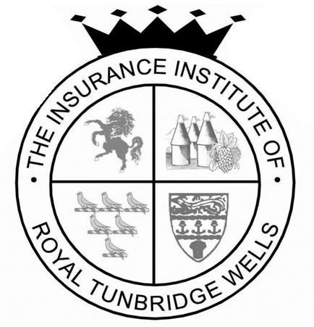

The Insurance Institute of Royal Tunbridge Wells
17th March 2017 Annual Dinner - Sponsorship Form

The Insurance Institute of Royal Tunbridge Wells is self funding and is looking for additional sponsors to support the Dinner.

The following options still available for sponsorship:

Table Menu (Printing) £100
Toast Master £400
Presidents Reception Drinks £250
Top Table Guests Drinks £250
Auction Items Various
Table flowers £250
Main entertainment £1,500

The following sponsorship has already been confirmed:

IDEX Consulting (London) Ltd – The Young Achievers Award

In return for Sponsorship we will do the following:-

- Website Notice: permanent notice on website leading up to the dinner and press release for your own internal notice/magazine
- President’s Speech: a mention of thanks in the President’s speech for supporting the institute
- Menu Cards: All sponsors names will be listed on the Menu Cards on the tables
- Invite to President’s pre-dinner drinks reception

For more information or to discuss other sponsorship options please contact Lizzy Dunning, The Dinner Secretary at lizzy_dunning@nfumutual.co.uk or you can telephone me on 07834452210

