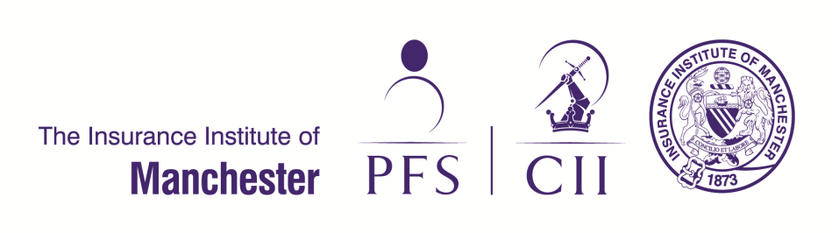

Style In The City

Friday 23rd June 2017 at The Midland Hotel, Manchester

A little party never killed nobody...

Think 1920s, The Great Gatsby, as the most talked about fashion show in Manchester returns for its 7th season!
Guests from the insurance and financial services industry and associated businesses will enjoy an afternoon of entertainment with a light lunch and drinks.

Guest Sponsor Package:
Exclusive 'Sponsor' table - 10 complimentary tickets (1 full table, tickets usually £85 each)
Event drinks provided on table - 3 x Prosecco, plus water provided
Two course sit down lunch for each guest - plus coffee and mints
Public acknowledgement by the host during the event
Exclusive sponsorship of a raffle prize - purchased in your name to the value of £50
Space for display - display 1m wide banner in reception or main function room
Networking opportunities - list of organisations attending and table numbers provided 2 weeks prior to the event

Your company logo will feature on:
- all pre event advertising emails (over 2,600 online members)
- the institute fashion show website page (over 2,000 overall IIM website sessions in June 2016)
- the event programme (375 guest tickets available for the event)
- the big screen at event
- the table plan boards prominently displayed at the event
- all promotional material

Package price: £1,600

Don't have a full table of guests?
Guest sponsor package for 2 tickets and a bottle of Prosecco: £900

CONTACT:

E: lii.manchester@cii.co.uk W: www.cii.co.uk/manchester T: 0161 236 2926

