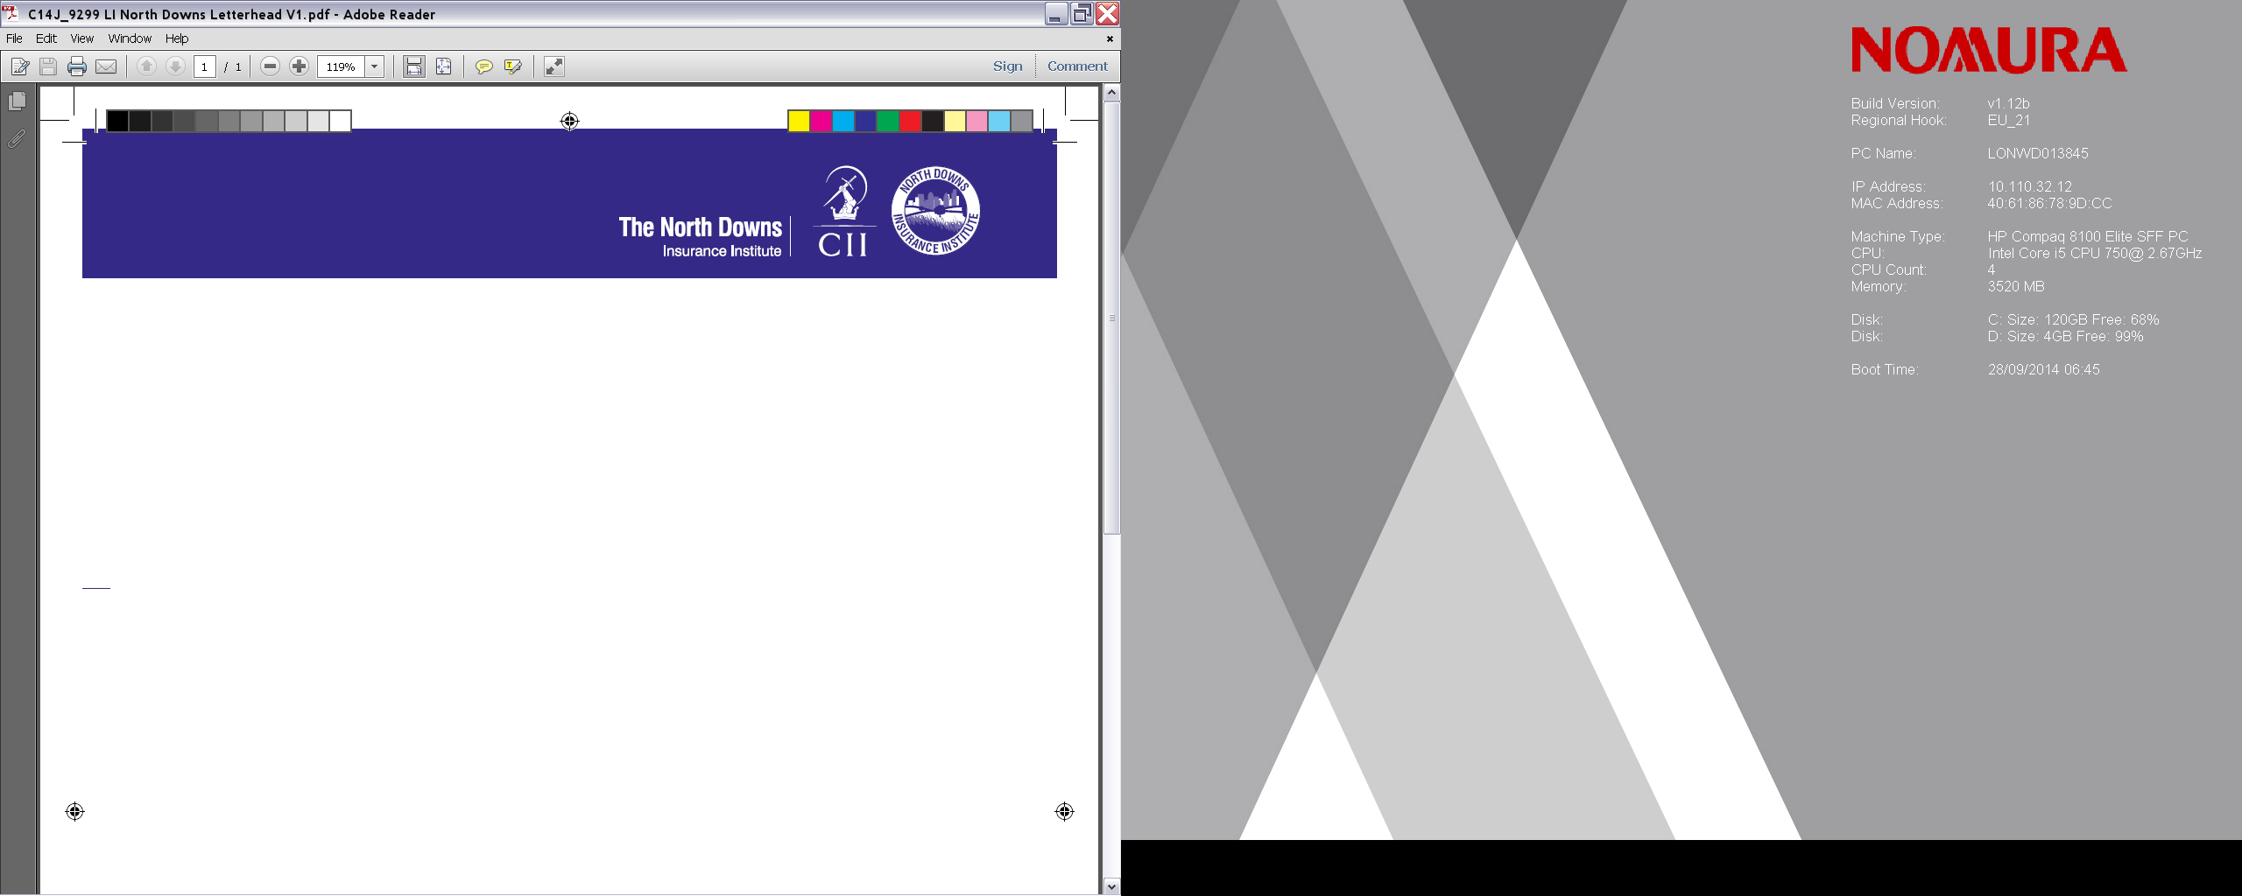
HALF DAY WORKSHOP – TUESDAY 18TH APRIL 2017 at
ZURICH INSURANCE CO LTD, 4th Floor,SUNLEY HOUSE, BEDFORD PARK, CROYDON
Times 9.00am -12.15pm (Registration 8.50am)
BUSINESS INTERRUPTION WORKSHOP

Presented by Damien Glynn – Head of Financial Risks, Vericlaim UK
Session Outline
- Key parts of the BI operative clause
- Meaning and scope of Damage, and the operation of the material damage proviso
- Examples of consequential losses that are not covered
- Key aspects of the Maximum Indemnity period (and why 12 months is insufficient)
- Calculation of Gross profit for insurance policies and key pitfalls
- Operation of ICW cover, and common misunderstandings
- Discussion of common BI extensions
Learning Outcomes
Attendees will gain an overview of BI wordings and at the end of the session will be more confident discussing/arranging BI cover with policyholders.
This session will allow attendees to:
- Obtain an understanding of how cover is provided by insurers
- Have an understanding of how the business interruption section of an insurance policy operates to provide an indemnity
- Be able to consider the implications of increase in cost of working expenditure
Speaker Biography- Damian Glynn BA (Hons), FCA, FCILA, FUEDI-ELAE, FIFAA Damian specialises in business interruption, fidelity guarantee, professional indemnity and other financial loss claims in the public and private sector, including world heritage sites, since 1993. He has particular expertise in the manufacturing sector and is a published author on BI issues. A past examiner for CILA business interruption exams, Damian is also chairman of the CILA Business Interruption Specialist Interest Group, and co chairman of the report issued jointly by IIL,CII, and CILA dealing with BI wording challenges highlighted by claims – the pdf version of this has now received over 150,000 hits. He has appeared in court as an expert witness both in his capacity as a Chartered Accountant, and as a Chartered Loss Adjuster
To book your place email to :- Administration Officer at ;-
davejp121 @gmail.com
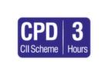
3 hours CPD can be claimed for this event if relevant to your learning and development needs.Visit www.cii.co.uk/cpd for more information

